GENERATION OF SERIES OF NUMBERS

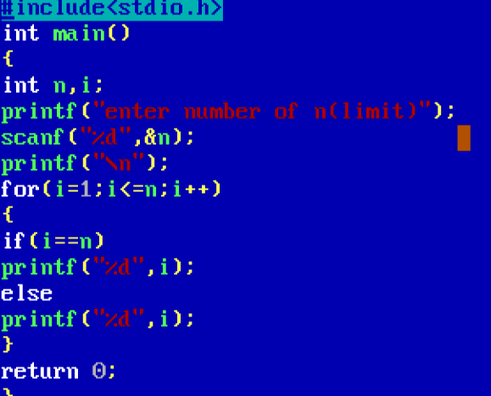

Output

